Section 2. General Information

HackerNest (See Appendix A, Figure 1 for Business Logo), founded on January 11, 2011, is a non-profit business that unities local technology communities around the world through community events such as hackathons and tech meetups. HackerNest hosts socially beneficial hackathons, where programmers, entrepreneurs, designers, and engineers collaborate intensively to create hardware and software, such as video games, robots, apps, and websites, to benefit the society in different ways. (See Appendix A, Figure 2 for photos of HackerNest’s Hackathons). Initially, HackerNest was founded in Toronto by 3 individuals with the goal of getting more people into technology so they can afford to live healthier and happier. (See Appendix A, Figure 3 for Headquarter Location). Over the years, this partnership business has evolved into a crown corporation that is supported by the Canadian government and the British government. In addition, HackerNest has a board of advisor and is sponsored by companies such as Facebook, Amazon, and Deloitte. (See Appendix A, Figure 4 for a List of Sponsors). The business’ headquarter alone has approximately 50 employees. (*LinkedIn*). HackerNest have been in business for seven years. Each month, HackerNest runs an average of 5 tech meetups, and each year, HackerNest hosts 6 to 7 hackathons. The most famous hackathon that HackerNest hosts yearly is the Dementia Hack, which draws hundreds of hackers to create life-improving hardware and software solutions for those living with dementia. (*HackerNest*).

HackerNest has been expanding nationally and internationally throughout the years. HackerNest names their subsidiaries “splinter cells”. (See Appendix A, Figure 5 for the Location of Subsidiaries). To date, HackerNest splinter cells have run over 250 events in over 23 cities, 12 countries, 5 continents. (*HackerNest*). HackerNest’s subsidiaries are run by volunteers who are dedicated to building strong, cohesive, supportive tech ecosystems while keeping the authentic, grassroots community that HackerNest have gained notoriety for. HackerNest’s first splinter cell emerged in 2013. In the same year, HackerNest hosted Canada’s largest hackathon and an international 8-city “Women in Tech” themed tech social. In 2014, HackerNest was recognized by Deputy Mayor Norm Kelly for contributions to the tech community in Toronto, was appointed to Toronto’s Advisory Council on Innovation and Technology, and attracted 1300+ registrants at its first-ever job fair. HackerNest continued to grow in 2015 and 2016; more socially beneficial hackathons were planned and hosted, and community-centric tech socials were spread to more international cities. In 2017, to continue its global expansion and influence, HackerNest should open up a subsidiary in Seoul, South Korea.

South Korea is a country in East Asia. It occupies the southern portion of the Korean peninsula, and is bordered by North Korea to the North, the East Sea to the east, the East China sea to the south, and the Yellow Sea to the west. (See Appendix A, Figure 6 for South Korea’s Geographical Location). According to the latest United Nations estimates, the population of the Republic of Korea is approximately 50.6 million, and 81.9% of the population lives in urban areas. The population of South Korea is growing in a declining rate. (See Appendix A, Figure 7 for Yearly Population Growth Rate Graph). In 2016, the yearly population growth rate is only 0.4%. (*Worldometers*). The declining population growth rate is one of the biggest social issues that South Korea faces. In a few decades, only few workers are available to pay taxes to support health care for the elderly, or to purchase goods or services that drive an economy. (*The Globe and Mail*). In the environmental aspect, South Korea is at risk from a variety of natural hazards such as landslides, winter storms, and tsunamis. However, typhoons and their accompanying floods are the most damaging natural disasters. In recent years, typhoons and floods have caused approximately 80% of all property damage from natural disasters in South Korea. (*AIR Worldwide*). For HackerNest, it is important that the business opens up a subsidiary in an area where natural hazard is unlikely to happen. In the past a few decades, as the country making its transition towards a consolidated democracy and an advanced market economy, political and economic challenges continuously confront. During the past two decades, South Korea has faced lingering problems such as poor governance, corruption, lack of leadership, social polarization, and political conflict. (*East-West Center*). In order to success in a foreign country, HackerNest must be aware of the political movement, follow the regulations and laws set by the government, and respect the country’s political views.

South Korea is one of the most ethnically homogenous nations in the world. To be more specific, over 97% of South Koreans identify themselves as ethnically Korean. (See Appendix A, Figure 8 for Ethnic Composition in South Korea). The largest minority group in South Korea is the Chinese. Recently, accompanied with South Korea’s rapid economic development, opportunities for foreign immigrants has increased. In 2007, the number of foreign citizens in South Korea passed the million mark for the first time. (*Study.com*). The official language in South Korea is Korean. The language itself has a number of dialects and the main dialect used in South Korea is the Hanguk dialect. English is used as a second language in South Korea. Though it is taught in schools, the majority of the population do not speak it freely. (*Study Country*). Therefore, to break down the language barrier and communicate freely with future sponsors, employees, and partners, HackerNest should hire someone who can speak both Korean and English freely to help with the foreign expansion. In South Korea, all the world’s major religions, including Christianity, Buddhism, Confucianism, Islam and Shamanism, coexist with each other. (See Appendix A, Figure 9 for Size of Religious Group). The diversity of religious belief has impacted South Korea’s social development. (*Korea.net*). As a result, HackerNest must understand the basic exercise and holiday celebrations of these religions.

HackerNest also needs to consider the time difference between South Korea and Canada before setting up meetings between the local subsidiary and the headquarter. The entire South Korea belongs to one time zone, which is 9 hours ahead of coordinated universal time. (*Time and Date*). Since South Korea is the world’s most wired country and Wi-Fi is ubiquitous through the country, the best way for HackerNest to communicate with its partners and headquarter is through the internet. Meanwhile, South Korea’s postal service is fast and reliable. Communicating with its consumers through postal service is recommended for HackerNest. However, South Korea does not have a GSM network, which means that mobile devices’ roaming opportunities are limited. (*Expat Focus*).

The transportation system in South Korea is greatly developed. The transportation system comprises railways, roads, subways, highways, waterways, and airlines. One of the most convenient ways to travel between cities in Korea is by train. The railways in South Korea is 3472 km long in total in 2005, while 1361km is electrified. (See Appendix A, Figure 10 for Railway Map). (*New World Encyclopedia*). Roads and highways in South Korea rapidly expanded during the late 1980s. The highway network serves all parts of South Korea, and by December 2008, the total length of the roads reached 104, 236km. Shipping is the primary way of importing and exporting products in South Korea. As one of the world’s most advanced technology exporters, South Korea operates one of the largest merchant fleets that sail to China, Japan, and the Middle East. Busan, Jeju, Masan, Incheon serve as Korea’s major ports for international shipping. (See Appendix A, Figure 11 for Map of Ports in South Korea). The total length of the waterways in South Korea is 1600 km, with most of the rivers span the mountainous terrain. (*Index Mundi*). Rivers have impacted South Korea’s culture, commerce, and society. For major port cities such as Seoul and Busan, rivers are crucial to the transportation of goods. Additionally, rivers also drive commerce with South Korea river tours and river cruises. In 1999, South Korea had 103 airports small and large. (See Appendix A, Figure 12 for Airports in South Korea). There are two airports that serve the capital city Seoul alone—Incheon International Airport and Gimpo International Airport. Incheon hosts most international routes while Gimpo hosts domestic flights. There are two major airlines in South Korea. Korean Air serves major domestic routes and offers international service to Canada. Asiana Airlines only serves three domestic cities. (*New World Encyclopedia*). Since employees of HackerNest may fly frequently between Seoul and Canada, HackerNest should consider becoming a VIP member of Korean Air.

HackerNest is expanding to Seoul, which is the capital city as well as the cultural, economic, and political center of South Korea. Seoul locates on the Han River in the northwestern part of the country. (See Appendix A, Figure 13 for Seoul’s Geographical Location). The population of Seoul is estimated at 10.29 million, which its population density is almost twice that of New York City. (*World Population Review*). HackerNest would enjoy the tech atmosphere in Seoul. Leading global electronics companies such as Samsung and LG, all have the headquarters locate in Seoul. (*CNN Travel*). Seoul is also the education centre of South Korea. (See Appendix A, Figure 14 for Picture of Seoul) Thus, HackerNest can find hackathon participants and volunteers easily. There are some other major cities in South Korea that HackerNest can expand to in the future. For example, Busan, the second largest city of Korea with a population of 8.2 million (*World Atlas*), would be a good choice because it is the trade centre and the largest industrial area of South Korea. (See Appendix A, Figure 15 for Picture of Busan). HackerNest should also consider expanding to Incheon after it successfully opens up a subsidiary in Seoul. (See Appendix A, Figure 16 for Picture of Incheon). Incheon is the third largest city of South Korea and is home to 2.9 million people. (*World Atlas*). As the major gateway for cultural and commercial trades between South Koreans and foreigners, Incheon will help HackerNest gain more publicity, creating opportunities for HackerNest’s further expansion.

Appendix A.



Figure 1.

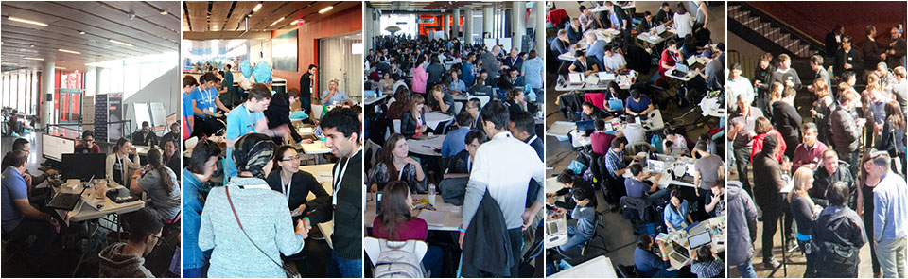

Figure 2.

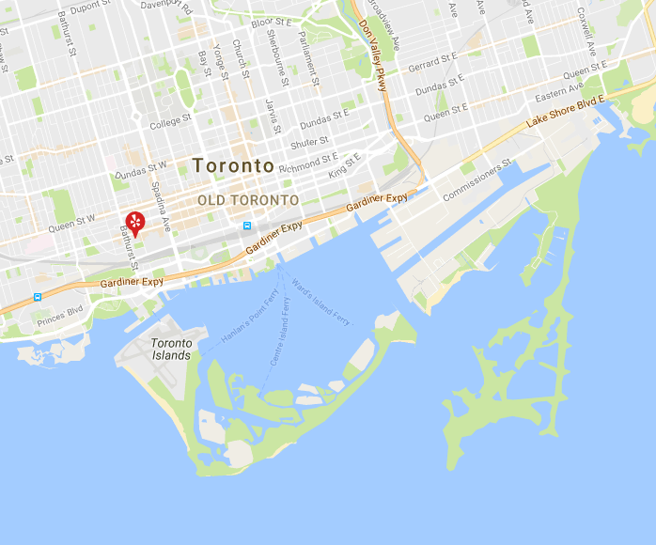

Figure 3.

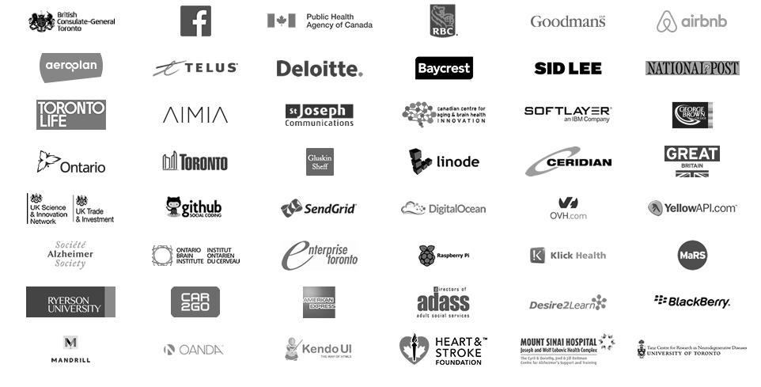

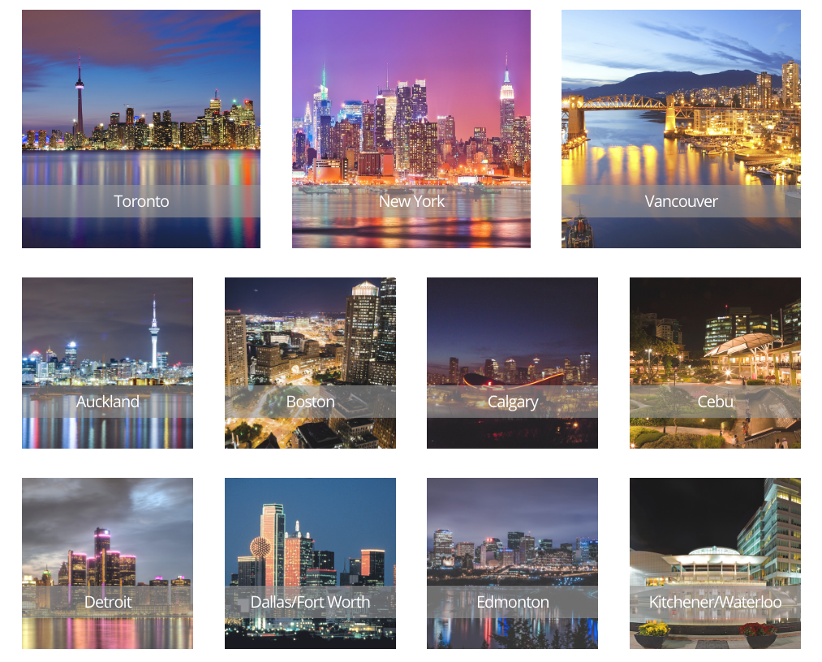Figure 4.

Figure 5.

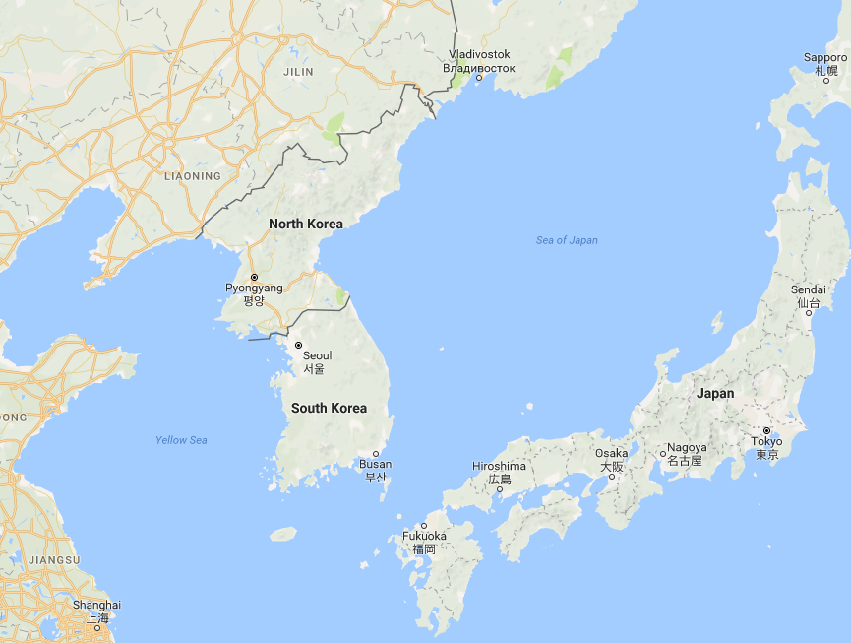

Figure 6.

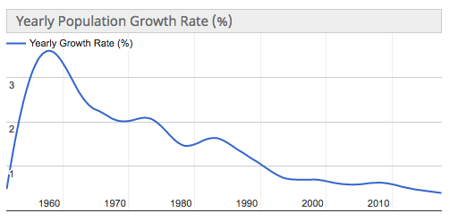

Figure 7.

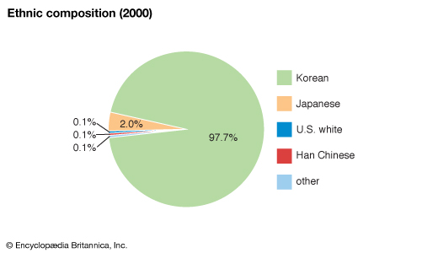

Figure 8.

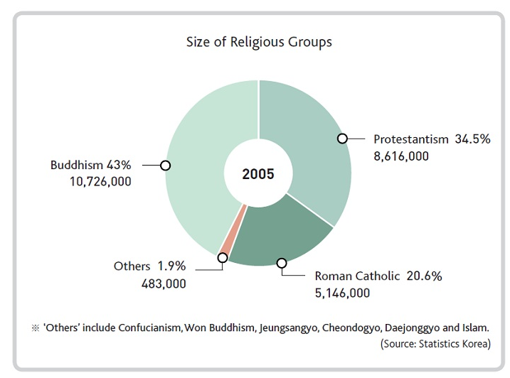

Figure 9.

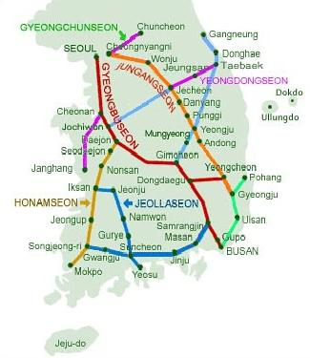

Figure 10.

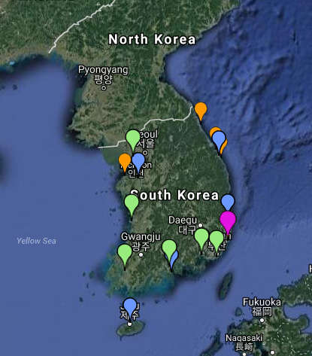

Figure 11.

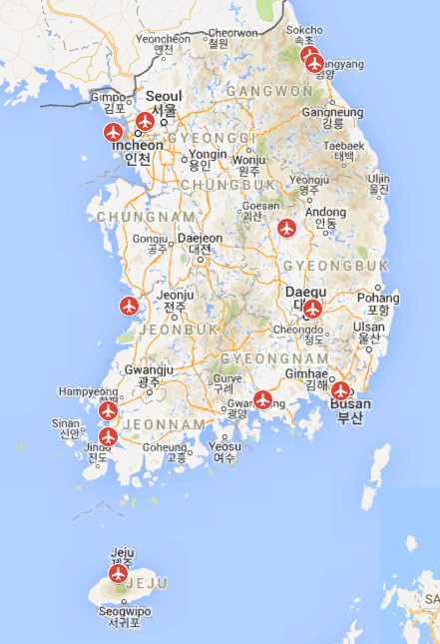

Figure 12.

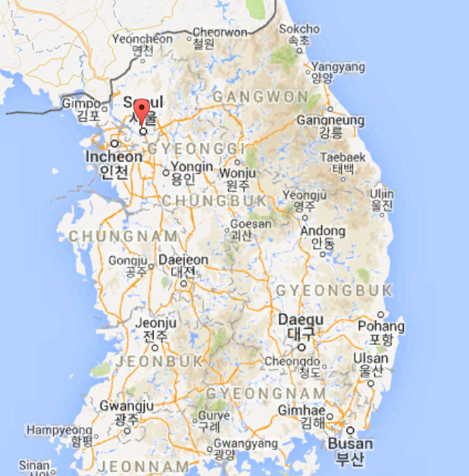

Figure 13.



Figure 14.



Figure 15.



Figure 16.

Works Cited

http://hackernest.com/

<https://www.linkedin.com/company-beta/2433801/?pathWildcard=2433801>

<https://www.britannica.com/place/South-Korea>

<https://www.britannica.com/place/Seoul>

<http://www.worldometers.info/world-population/south-korea-population/>

<http://www.theglobeandmail.com/news/world/a-bleak-future-and-population-crisis-for-south-korea/article21249599/>

<https://www.air-worldwide.com/Publications/AIR-Currents/2010/Managing-Typhoon-Risk-in-South-Korea/>

<http://study.com/academy/lesson/south-korea-ethnic-groups.html>

<http://www.studycountry.com/guide/KR-language.htm>

<http://www.korea.net/AboutKorea/Korean-Life/Religion>

<https://www.timeanddate.com/worldclock/converted.html?p1=235&p2=250>

<http://www.expatfocus.com/expatriate-south-korea-communications>

<http://english.visitkorea.or.kr/enu/TRP/TP_ENG_4.jsp>

<http://www.newworldencyclopedia.org/entry/Transportation_in_South_Korea>

<http://www.indexmundi.com/south_korea/waterways.html>

<http://worldpopulationreview.com/world-cities/seoul-population/>

<http://travel.cnn.com/seoul/life/50-reasons-why-seoul-worlds-greatest-city-534720/>

<http://www.worldatlas.com/articles/biggest-cities-in-south-korea.html>

<http://www.eastwestcenter.org/research/visiting-fellow-programs/posco-visiting-fellowship-program/political-aspects-of-korea-related-issues>

<https://www.google.ca/url?sa=i&rct=j&q=&esrc=s&source=images&cd=&cad=rja&uact=8&ved=0ahUKEwjswOzsmb3TAhWrx4MKHQT4BmsQjRwIBw&url=%2Furl%3Fsa%3Di%26rct%3Dj%26q%3D%26esrc%3Ds%26source%3Dimages%26cd%3D%26cad%3Drja%26uact%3D8%26ved%3D0ahUKEwiA19Xmmb3TAhWe0YMKHV-1DnIQjRwIBw%26url%3Dhttps%253A%252F%252Ftheraillife.wordpress.com%252F2013%252F03%252F19%252Fsouth-korea-korail%252F%26psig%3DAFQjCNHWKXmWU7MuESZ-e-tV2oavVJiWTA%26ust%3D1493127036376097&psig=AFQjCNHWKXmWU7MuESZ-e-tV2oavVJiWTA&ust=1493127036376097>